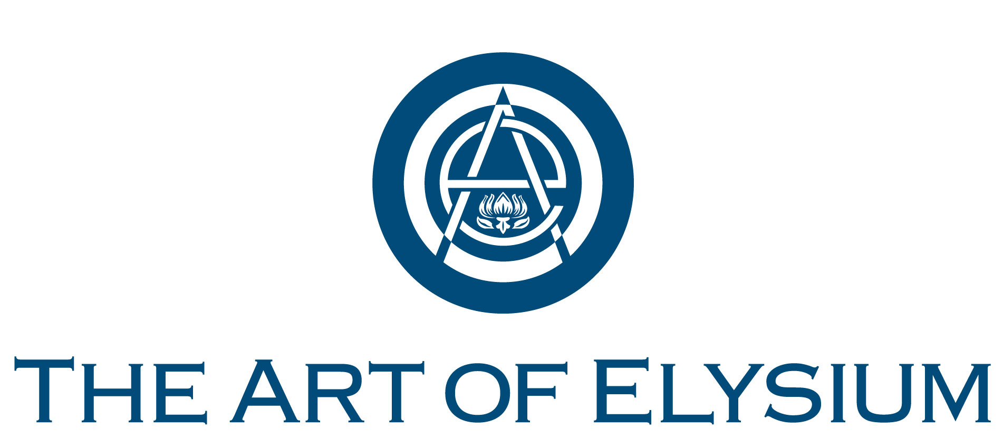

BOARD MEETING NOTES
Wednesday, December 11, 2019
Via Teleconference

- Welcome
Present: Board Members: Justin Bartha, Ken Coehlo, Bill Harrison, Jennifer Howell, Matt Meza, Ragan O’Reilly, Lauren O’Reilly
Staff: Leslie Culp, Jennifer Howell
- Program Numbers From Leslie Culp: 2018 Final Individuals Served: 30,441, number of workshops in the community: 1,325, number of artists volunteers: 1,889, number of volunteer hours: 96,679.85, number of artists served: 2,077, number of community exposure: 3,224
- HEAVEN 2021: outreach needed from your databases. VISIONARY: WE ARE HEAR, SPIRIT OF ELYSIUM Recipient: Ashley & Topher Grace, VOLUNTEER ACHIEVEMENT Award: Danny Kastner
- Ken Coehlo: review of financial plan for taxes, audit and financial adjustments with Gerber Financial.
- Board terms and 2020 plans to be discussed at the top of next year.
- Meeting adjourned.

